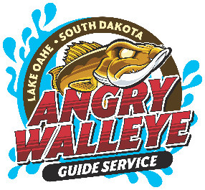
RELEASE, INDEMNIFICATON AGREEMENT, AND CONSENT
I/We, ___________________________________________, on Behalf of him/herself or group associated with, ourselves, and said respective agents, insurers, heirs, executors, administrators, successors and assigns, acknowledge that I/we may be going in unfamiliar, and potentially risky, territory for the Angry Walleye Guide Service or Dark Knight Empire LLC expedition may be in a variety of uncontrolled atmospheres and conditions; and
THEREFORE, I/we hereby discharge, release, indemnify and hold harmless Angry Walleye Guide Service of South Dakota and all of its agents, employees and associated personnel, including either paid or volunteer assistants, from any and all actions, proceedings, claims, demands, incidents, suits, causes of action of any kind, of any nature or description, or any other liability and against all losses, costs, damages, expenses, or attorney’s fees arising out of, connected with, or resulting in relation to the fishing/water activities provided to me/us by Angry Walleye Guide Service or its Sponsors.
I/we also further acknowledge that individual and/or group photos or videos may be taken during the guide service, and therefore, I/we on behalf of him/herself , ourselves and said respective agents, insurers, heirs, executors, administrators, successors and assigns, agree and consent that Angry Walleye Guide Service , its sponsors, and all said parties have my/our full permission for my likeness to be taken during the guide service event and to use any image, photograph, video clip, or other similar image, in any media format taken, for advertising purposes, promotional purposes, or any purpose deemed necessary by Angry Walleye Guide Service. I further release Angry Walleye Guide Service from any liability for any adverse result which may come from the use of the above-mentioned photograph(s) or media images.
I/we also hold harmless Angry Walleye Guide Service and all of its agents, employees and associated personnel, including either paid or volunteer assistants, from any and all actions, proceedings, claims, demands, incidents, suits, causes of action of any kind, of any nature or description, or any other liability and against all losses, costs, damages, expenses, or attorney’s fees arising out of, connected with, or resulting in relation to any person consuming alcohol or illegal drugs.
Dated this ________day of _________________, 20______.
Signatures __________________________________________________________________________________________________
__________________________________________________________________________________________________.
Printed Names __________________________________________________________________________________________________
__________________________________________________________________________________________________.
Witness ___________________________________________________________________________________________.
Thank you for choosing Angry Walleye Guide Service.
Scan the QR codes for easy access online.
